Review of Australia’s Humpback Whale Populations

Meeting at the Sydney Harbour Institute of Marine Science
17th and 18th April 2008

Host:
The Australian Marine Mammal Centre (AMMC) formerly the Australian Centre for Applied Marine Mammal Science (ACAMMS).

Participants:

John Bannister
Mark Bravington
Dan Burns
Chris Burton
Mike Double
Rebecca Dunlop
Wally Franklin
Nick Gales
Rob Harcourt
Peter Harrison
Amanda Hodgson

Curt Jenner
Natalie Kelly
Rob McCauley
Mike Noad
Dave Peel
David Paton
Milena Rafic
Chandra Salgado-Kent
Josh Smith
Sam Thalmann

Purpose: The purpose of this review was to assess the historic and current efforts to estimate trends and abundance of humpback whales on the east and west coasts of Australia (Breeding stocks D and E), and to develop recommendations of how to proceed with this work into the future.

- Summary of historic and current survey work of breeding stock D (Western Australia)

A summary of Australia’s west coast humpback whale population was presented including the history and magnitude of coastal and pelagic whaling and the outcomes of recent studies estimating abundance. Aerial surveys between 1976 and 1994 showed the population was increasing at a rate of approximately 10% per year (Bannister and Hedley, 2001). In 1999 an aerial survey of northbound humpacks migrating past Shark Bay provided a total abundance estimate of 8200 to 13650 whales. In 2005 a combined aerial and land-based survey (Dirk Hartog Island) gave a population estimate of 12,800 (95%CI: 7,500-44,600). This estimate was not statistically different from the 1999 survey.

An AMMC funded aerial and land-based survey is planned for mid 2008 in the Shark Bay/Dirk Hartog Island region.

- Summary of historic and current survey work of breeding stock E (Eastern Australia)

A summary of recent studies that estimated the size of the east coast population of humpback whales was presented. Land-based surveys from Stradbroke Island have provided abundance estimates from 1981 to 2004. Although the surveys have used different methods and survey locations the estimates show remarkable congruence. These surveys indicate the population is increasing at approximately 11% per year. The 2004 survey based at Point Lookout, Stradbroke Island estimated the population size to be between 6430 and 7750 whales (Noad et al., 2006). This survey was repeated in 2007 and together with previous estimates suggests the current population size of the East Australian population is approximately 9700 whales. Importantly the 2007 study also include aerial surveys which suggest that approximately 30% of whales are not recorded by the land based surveys. This 2007 dataset requires further analysis to obtain a population estimate and also verify the proportion of whales missed by the land-based survey station.

Data sets from other sites along the east Australian coast exist but have yet to be analysed formally. Survey data from Cape Solander were highlighted as potentially valuable. It was noted that counts from southern NSW tend to be lower than those further north probably because the migratory corridor is wider further south. Compilation and analysis of these datasets was considered to be a high priority.

A 2005 multi-site photo-identification mark-recapture study produced an abundance estimate for east coast humpback whales of 7024 (95% CI: 5163-9685) (Paton et al., in press). This value is remarkably similar to the corresponding abundance estimates from land-based surveys.

It was noted that datasets exist that could relate the offshore distribution of migratory whales to local oceanographic conditions. These data have yet to be analysed.

- Survey design

The following components of survey design were identified as influential and were discussed at length:

- Estimating g(0) (proportion of whales on the transect line that were not observed)
- Quantifying interval (down) times and swimming speeds
- Cue counting
- Quantifying pod size from land-based and aerial surveys
- Survey duration to describe migratory period
- Aerial survey coverage and distribution of whales offshore
- Sources of heterogeneity – (e.g. observers, sea state, time of day etc.)

These discussions highlighted the utility of synchronous land-based and aerial surveys. Aerial surveys provide greater coverage and a description of the distribution of whales from shore, whereas land-based survey stations provide an estimate of g(0) for the aerial survey and can better quantify pod sizes, interval times and swimming speeds. The outcomes of these discussions were incorporated in the design and coordination of the surveys planned for west Australia in mid 2008 (see below).

- Future of west Australian surveys

The mid 2008 aerial and land-based survey based in the Shark Bay region of Western Australia will continue largely as planned (land-based counting based at Dirk Hartog Island). Longer flights were recommended to ensure accurate definition of the migratory corridor.

The Shark Bay survey location was questioned because of flight times and accessibility of land-based survey site. Exmouth was proposed as an alternate site. Land-based surveys cut costs but suitable sites are limited in west Australia because the whales tend to be further offshore. Cape Cuvier was the only site suggested in the Exmouth region. It was suggested that Floating Production Storage and Offloading (FPSO) vessels in the Exmouth region could affect the location and width of the migratory corridor.

The meeting was told that an industry-funded aerial survey planned for the Exmouth region in 2008 could complement the Shark Bay survey if the data are collected in a similar manner. The principal investigators of both surveys agreed to match the methodologies of the two surveys as closely as practically possible.

Both surveys agreed to fly at height of 1500 feet and a speed of 120 knots. Both surveys will use a box-shaped flight pattern and fly at approximately the same time of day.

The Exmouth survey will:
- fly further south and further offshore than originally planned (subject to additional funding).
- conduct at least 15 flights at 10 day intervals but the interval may be reduced
- employ line transect methodology but not cue counting
- consider double observers on a single side of the aircraft to estimate g0
- calculate swim speed and dive profiles from past data
- consider using g0 from the Shark Bay survey after careful consideration
- consider, for future studies, using data from Cape Cuvier to assess g0 future work
The peak of the northward migration in the Exmouth region occurs between the 13th and 29th July.

The Shark Bay survey will:
- conduct aerial surveys between the 20th of June and 20th of August
- conduct up to 30 flights over the 2 month period (weather permitting)
- consider using both cue counting (see below) and standard line transect methodologies
- conduct land-based double count survey off Dirk Hartog Island for two weeks during the peak of the migration
- use Cyclopes on all 3 platforms for data collection
- conduct land-based focal follows to assess swim speeds and dive profiles
- use data from the land-based survey to assess distribution of pod sizes
- will consider increasing the survey effort over the transect that the land-based group can see and match groups using Cyclopes – this attempts to assess whether aerial data consistently underestimate pod sizes
The peak of the northward migration in the Shark Bay region occurs between the 7th and 21st July.

It was noted that to standardize covariates between the two surveys then the same observers would need to be swapped between locations. Also it cannot be assumed that whale availability (dive profiles and swim speeds) do not differ between the two sites.

Although cue counting is currently planned for the aerial surveys off Shark Bay it was noted that collecting such data along with standard line-transect data place too great a demand on the observers particularly when the whales are in high densities. John Bannister, Sharon Hedley and Mike Noad will discuss this matter further and decide on the most appropriate strategy.

Sharon Hedley will analyse all data collected from the Shark Bay survey. It was considered desirable that Rebecca Dunlop and Chandra Salgado closely follow the analytical process.

- Future of east Australian surveys

Abundance estimates
It was clear that the repeated estimates of abundance and the congruence between counts provided powerful data for estimating rate of recovery and contemporary abundance. The principal survey site at Point Lookout, Stradbroke Island was considered adequate but other sites nearby may provide more height and a greater field of view. Also these nearby sites may be more similar to those used in earlier surveys. The cost of conducting surveys from this site is relatively small.

A growing problem for the surveys at Point Lookout is the large number of pods that pass the survey site at the peak of the migration. This causes confusion and the data collected during this period may be less reliable. It is likely this problem will grow as the population continues to grow. Consideration was given to reducing the field of view used by the spotters.

Although a previous study suggested all whales were close enough to Point Lookout to be counted (Brown et al., 1995) aerial surveys in 2007 found approximately 30% of whales may not be visible from shore. Future studies need to provide a better estimate of the proportion of whales not visible from the chosen survey site.

Breeding sites/Calving grounds
The meeting agreed that it is still not known if the whales migrating along Australia’s east coast constitute a single (E1) breeding stock. Resolution of this issue remains a high priority.

Following the meeting Megan Anderson (Southern Cross University) provided a summary of provisional results from genetic analyses being conducted as part of her doctoral studies. Her data suggest genetic structure between east Australia and Oceania and also structure within Oceania. Significantly the data also suggest structure between sampling sites within eastern Australia. This may reflect mixing and separating of whales from the Oceania populations at different points along Australia’s east coast.

It was acknowledged that the calving grounds of the east Australian population, thought to be somewhere within the Great Barrier Reef (GBR), remain poorly defined. Given the growing recreational use of this region the meeting considered that research which led to the definition of the calving area to be a high priority.

Scientists from Southern Cross University proposed a broad-scale aerial survey over the Whitsunday Islands and the southern GBR. It was encouraged that the survey area be as large as logistically possible. It was acknowledged that existing datasets could not define the spatial distribution of the east Australian calving grounds.

It was recommended the SCU approach GBR Marine Park Authority to discuss the management pressures within the GBR and the necessity to manage recreational and commercial activities around calving whales. It was also recommended that SCU approach Coastwatch who may be able to provide useful information to guide the planning of the aerial surveys.

If reliable satellite tags become available then this technology will also assist in the identification of the calving area(s).

It was recognised that it was not known if humpback whales occurred around Chesterfield Island. Acoustic loggers could provide an index of abundance and temporal activity of humpback whales in this region.

- The need for annual or multi-annual surveys

As humpback populations recover from past catastrophic whaling activity it is likely that this species will become a sentinel species for the health of the Southern Ocean and Antarctic ecosystem. However, the principal objectives remain the monitoring of the population’s growth rate and the early detection of a slowing in the population’s growth.

The meeting questioned the appropriate interval between surveys if it was desirable to detect, as soon as possible, when the growth rate of the population begins to decrease. The ability to detect a slowdown is one criterion that might be used for deciding how often to survey (and, in particular, when to do the next one).

Detecting a decrease in growth rate will indicate that the population is approaching its carrying capacity (K) and then the final capacity can be better estimated. It is likely that the current K is now different from that prior to pre-exploitation due to environmental changes on both the feeding and breeding grounds. Predicting K will also allow an assessment of how a humpback whale population of size K may affect, and be affected by, activities such as tourism, fishing and industry.

Currently rate of increase is not well characterized for the west coast population so this modelling exercise was based on the population trajectory of the east coast population.

Abundance data suggest the east coast humpback whale population has been growing by 11% per year for the last forty years. Although there is no sign of a slowdown yet, the rate will slow as the population approaches K. Given that: 1) K, prior to exploitation, is estimated to be in the range of 20-30,000 individuals (Johnston and Butterworth, 2005); 2) the 2007 population estimate is 9600 (Noad pers. comm.) and 3) population estimates may be negatively biased; it is plausible that the decrease might be detectable soon.

By using two growth models (an unconstrained exponential model that continues the trend of recent years, and a modified logistic model that incorporates a limiting carrying capacity), it is possible to calculate when the difference between the population sizes predicted by the two models is sufficiently large to be detected by a single survey (i.e. to reject the "null hypothesis" of exponential growth at the 95% level). Inevitably the answer depends on our assumption of the current carrying capacity for this population. If we assume that K=20,000, then a significant slowdown could be detected in three years (2010) whereas if K=30,000 the slowdown would not detected until 2012 (see Figures 1 and 2).

These models assume that MSYL (the proportion of K at which annual growth rate is highest) is 60% as per the International Whaling Commission. The other key assumption is that the survey CV will remain at 2.5%. Any reduction in the survey's temporal coverage would increase the time interval before slowing growth rate can be detected.

It is important to note that Figure 1 and 2 show that the modified-logistic and exponential growth models give indistinguishable trajectories and so the data cannot yet be used to predict future abundance levels (K).

In summary, any single survey prior to 2010 is unlikely to detect a slowing in the population’s growth rate. Also if a survey in 2010 failed to detect a slowing growth rate then the data are still consistent with a K of 30,000. Only a survey in 2012 would be able to detect a slowing growth rate if the current carrying capacity of the population is 30,000.

The meeting thanked Mark Bravington for conducting this modelling and explaining carefully the model’s assumptions and predictions.

- Issues that affect abundance estimates that require greater resolution

Sex ratio
It was acknowledged that several studies from both the northern and southern hemisphere suggest a male-biased sex ratio on the migratory routes and breeding grounds of humpback whales (e.g. Wiley and Clapham, 1993; Brown et al., 1995). This suggests that abundance estimates from these areas may underestimate total population size and that perhaps all animals do not migrate to the breeding grounds each year.

Concerns were raised around the ability to obtain a random sample of animals if the sexes behave very differently. It was noted that existing datasets could go further to reveal the reliability of reported sex ratio biases. A migration-wide survey based at Point Lookout, Stradbroke Island was suggested where boat-based sampling could be conducted alongside a land-based assessment of how cues, distance from shore and others factors may introduce bias.

The meeting considered that the analysis of existing datasets to verify and quantify sex ratio biases to be a high priority.

Female fecundity and female return rates
The meeting recognised that the current rate of increase observed in both the west and eat coast populations (10-11% per annum) suggest that [some] females are producing calves in consecutive years.

It was noted that the existing Hervey Bay dataset and data held by the Pacific Whale Foundation (PWF) may show that females are observed with young calves in consecutive years. The PWF reported such data to the IWC Comprehensive Assessment meeting in Hobart in 2006. It was recognised that the Hervey Bay dataset is likely to yield the most convincing data. It was noted that Lyndon Brook will be collaborating with Ken Pollock to assess the value and potential outcomes from the Hervey Bay dataset. The meeting suggested that the analysis of return rates and individual reproductive success should be given high priority.

Work continues on methods to identify pregnant females from sampling whale blows.

Individual health and annual reproductive success
Currently no datasets or surveys exist that can be used to estimate annual productivity. The group considered various sites where female and calves could be counted. Generally it was thought that an assessment of annual productivity is not a priority at present.Also there are no established methods to assess the health of individual whales. It was acknowledged that the development of methods may be useful but large projects would not be appropriate at this stage.

Nocturnal behaviour
Currently abundance estimates assume that the migratory behaviour of whales does not differ from day to night. However, this has not been shown quantitatively. It was recognised that nocturnal migratory speed could be assed through: 1) infra-red cameras; 2) satellite tags; 3) radio tags; 4) sub-dermal acoustic tags; and 5) multi-site fluke-matching. Again existing data sets may help resolve this issue and the presentation of such data was considered to be a high priority. However, it was considered that it was unlikely that the behaviour will differ greatly over 24 hours and directed studies should be a low funding priority at present.

- Fluke matching software

The fluke-matching software developed by Eric Kniest and Southern Cross University was demonstrated to the meeting. The software performed extremely well on a small dataset and trials will now expand to a larger set of photographs. The meeting congratulated the development team on such significant progress.

- Other issued discussed related to the recovery, distibution and management of Australia’s humpback whale populations

Distribution of breeding stocks in feeding grounds
The meeting acknowledged that the distribution of breeding stocks in the Antarctic region is poorly understood and resolving the distribution is a high priority. Without such information catch data cannot be correctly associated with breeding populations and therefore estimates of pre-whaling abundance will be inaccurate.

The proposed yacht based expedition to Eastern Antarctica planned by AMMC and the Australian Antarctic Division for 2008/09 was described and discussed. This project will focus on humpback and minke whales and will collect acoustic data, biopsy samples, small and large-scale tracking data, and photo-identification data. The expedition will help resolve the distribution of Australian breeding stocks in East Antarctica. The particular areas to be traversed within the Antarctic region have yet to be defined. To maximize the value of data from this expedition the fluke photographs and biopsy samples, for example, will be readily shared with the wider scientific community.

The meeting was also informed that Australia will take a proposal to the IWC for a Southern Ocean Research Coalition. Such a Coalition will increase the capacity for non-lethal cetacean research in the Southern Ocean. The proposal will include provisions for centralised data depositories and full data sharing.

Work continues on the development of genetic tools to quantify age in cetaceans.

Trials continue on the development of reliable satellite tags for large baleen whales. The latest trial showed improved implantation but the tags only relayed data for a few days to a couple of weeks. It is becoming clear that longer tags are required to provide tracking for several weeks to a few months. Tags are required to describe migratory corridors, breeding grounds, feeding grounds the impact of seismic surveys (and other sources of offshore noise) therefore the development of reliable satellite tags remains a high priority.

- Permitting , data management and data sharing

The meeting was informed that federal permits for biopsy sampling can now only be issued once a permit to access biological resources in Commonwealth areas has also been granted. This permit will be also sought through the Cetacean Policy and Recovery Section who will mange the process on behalf of the Genetic Resources Management Section of Parks Australia. It was noted that questions are being raised with federal permitting groups over the necessity to collect biopsy samples every year. Prior to seeking permits researchers should carefully consider the necessity to collect biopsy samples and if existing samples could adequately address the research question.

The meeting supported the creation of a central repository for biopsy samples managed by AMMC. The associated database would show what samples are in the collection and manage requests for access to samples. The meeting accepted that it would be a reasonable permitting requirement for subsamples of biopsies to be submitted to a national repository with the provision that collectors retained ownerships rights for at least three years.

The meeting discussed the advantages of establishing a centralised database for individual identification of humpback whales and other cetaceans. It was recognised that the Intellectual Property rights of the data collectors would have to be well protected to ensure engagement in such an enterprise. The meeting strongly encouraged the development of a central database and it was recognised that AMMC currently has the capacity to provide such a facility. It was decided that a Steering Committee will be established to guide the development and management of the database.

- AMMC grants

The meeting was reminded that the AMMC grant scheme is partly funding by the Commonwealth Environment Research Facilities (CERF) and the Natural Heritage Trust (NHT). The NHT program is now complete and funding has not yet been secured from the replacement program Caring for our Country. AMMC will continue to seek a secure, long-term funding source for the grant scheme.

- Future workshops

The meeting recognized the value of the Distance Sampling Workshop held prior to the meeting. Such workshops increase the capacity of Australia’s marine biologists to design surveys and subsequently collect and correctly analyse complex datasets. Mark recapture analysis and spatial modelling were identified as possible subjects for future technical workshops but funding sources need to be identified.

The meeting again emphasised that the appropriate analysis and publication of existing datasets is a high priority and that there is now statistical capacity within AMMC to assist in survey design and analysis of survey data.
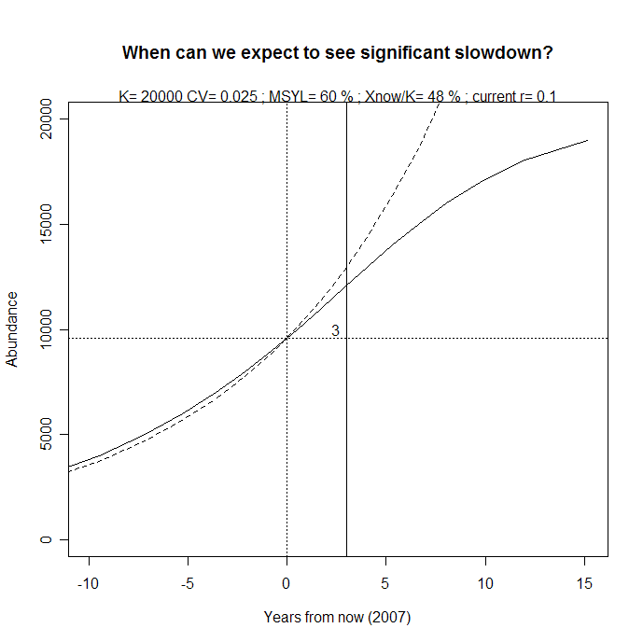
Figure 1. A slowing of the growth rate will be detectable in three years from 2007 (2010) if the carrying capacity of the population (K) is 20,000 individuals. Dotted line represents exponential growth; solid line represents modified logistic growth.
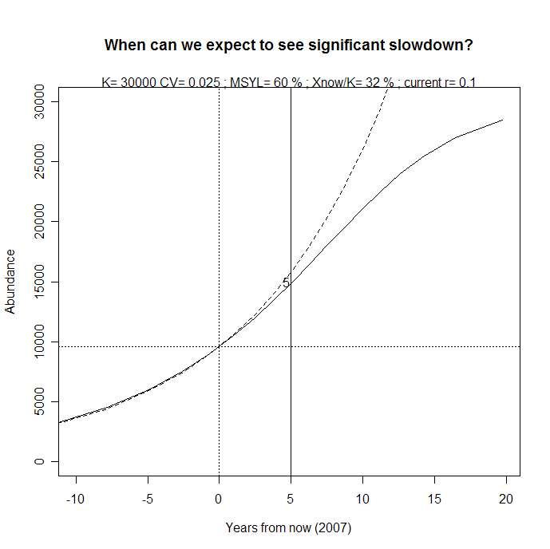
Figure 2. A slowing of the growth rate will be detectable in five years from 2007 (2012) if the carrying capacity of the population (K) is 30,000 individuals. Dotted line represents exponential growth; solid line represents modified logistic growth.
References

Bannister, J.L., Hedley, S.L., 2001. Southern Hemisphere Group IV humpback whales: their status from recent aerial survey. Memoirs of the Queensland Museum 47, 587-598.
Brown, M.R., Corkeron, P.J., Hale, P.T., Schultz, K.W., Bryden, M.M., 1995. Evidence for a sex-segregated migration in the humpback whale (Megaptera novaeangliae). Proceedings of the Royal Society B: Biological Sciences 259, 229-234.
Johnston, S.J., Butterworth, D.S., 2005. A Bayesian assessment of the west and east Australian breeding populations (Stocks D and E) of southern hemisphere humpback whales. SC/57/SH15. Paper submitted for consideration by the IWC Scientific Committee.
Noad, M.J., Paton, D., Cato, D.H., 2006. Absolute and relative abundance estimates of Australian east coast humpback whales (Megaptera novaeangliae). SC/A06/HW27. Paper submitted to the International Whaling Commission sub-committee for the assessment of Southern Hemisphere humpback whales, Hobart, April 2006.
Paton, D.A., Brooks, L., Burns, D., Franklin, T., Franklin, W.H., P., Baverstock, P., in press. Abundance of east coast Australian humpback whales (Megaptera novaeangliae) in 2005 estimated using multipoint sampling and capture-recapture analysis. SC/A06/HW32. Submission for special volume on the Comprehensive Assessment of Southern Hemisphere humpback whales, Hobart, April 2006.
Wiley, D.N., Clapham, P.J., 1993. Does maternal condition affect the sex ratio of offspring in humpback whales. Animal Behaviour 46, 321-324.

